Save the Files in the format Given Below

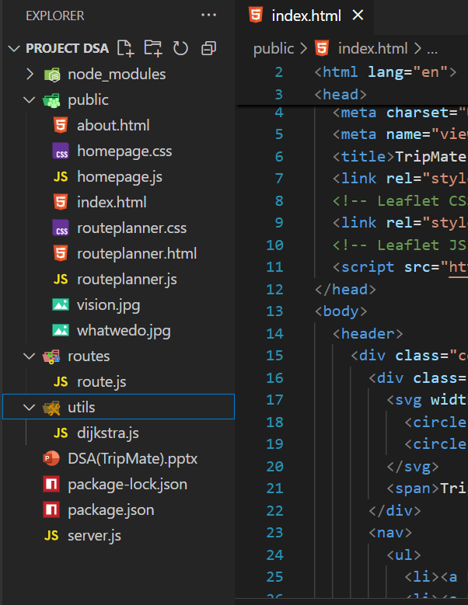

Now

Install Packages

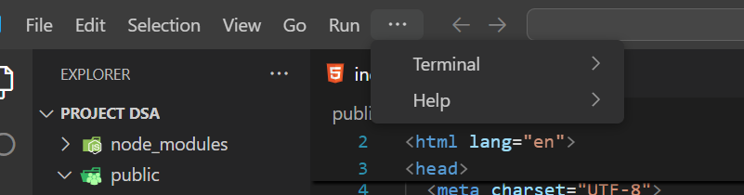

In terminal Select a new terminal

Type cd in the terminal (for windows)

Then type npm install express cors

This will install packages required for the project to run in backend

Then type node server.js

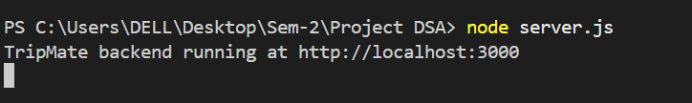

Now you will get a link like <http://localhost:3000>

Copy that link and open it in browser

This ensures that backend is running perfectly